# Alur Sistem Aplikasi CRUD Data Mahasiswa Menggunakan Bahasa Pemograman Pyhton

## Main menu

Description:

When run, the program immediately presents an interactive menu that makes it easy for users to use this data CRUD application.

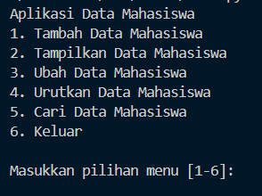

## First menu (Create Student Data)

Description:

In this first menu, users can enter the desired student data in a structured manner.

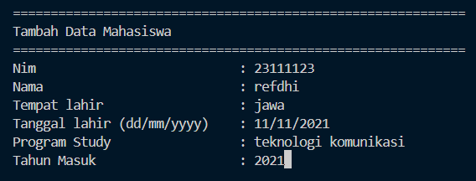

## Second menu(Read Student Data)

Descriptiom:

This second menu will display the student data table that has been inputted from the first menu.

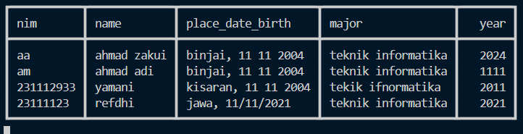

## Third menu(Update Student Data)

Description:

on this menu, allows users to change data that already exists in the table, based on name or nim.

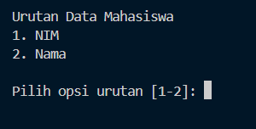

If selecting NIM then, the user must input the appropriate nim in the previous data and change the data as desired. Likewise, if selecting NAMA.

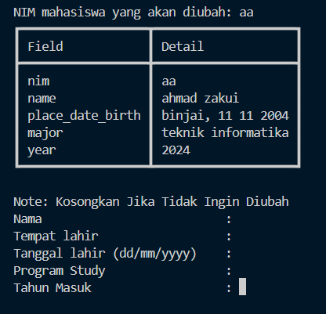

## Fourth menu(Sorting Student Data by Field)

Description:

in the fourth menu the user will be given the option to sort the data according to the options provided.

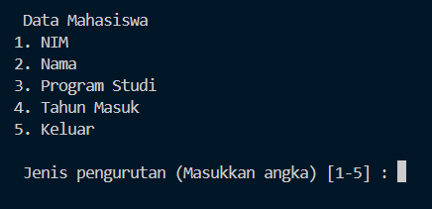

if the user selects the NIM option, the data will be sorted by NIM.

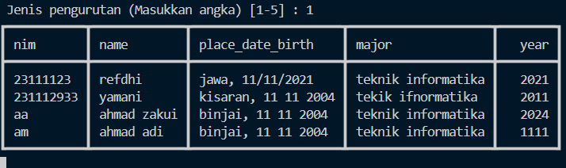

if the user selects the Nama option, the data will be sorted by Nama.

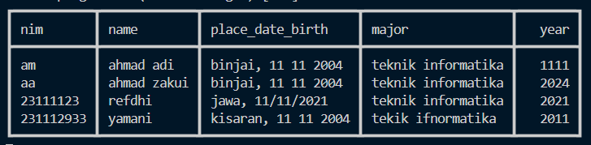

if the user selects the Program Studi option, the data will be sorted by Program Studi.

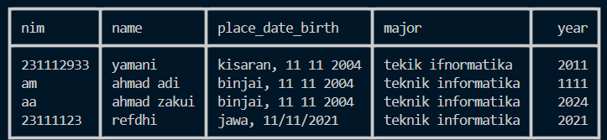

if the user selects the Tahun Masuk option, the data will be sorted by Tahun Masuk.

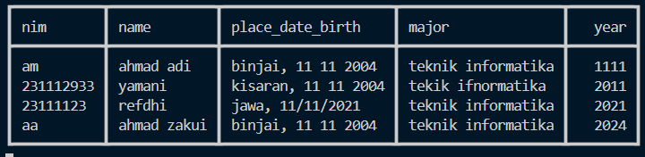

## Fifth menu(Search Student Data by NIM, Name)

Description:

in this menu the user is allowed to search for the desired student data with the NIM and Name options.

if you choose the NIM option, then the student data search will be based on the NIM inputted by the user and if the input is correct, it will display the student data.

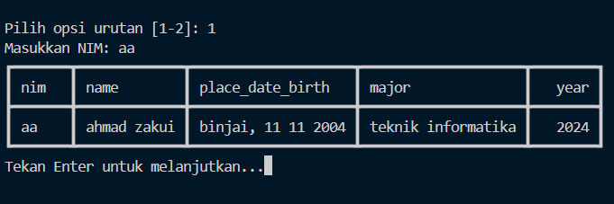

if you choose the Nama option, then the student data search will be based on the Nama inputted by the user and if the input is correct, it will display the student data.

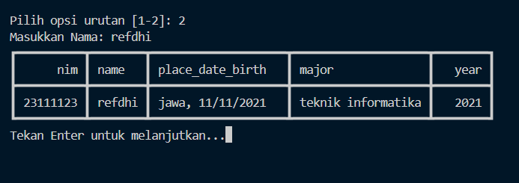

if the user inputs data that does not match then no data is displayed and the user will be asked to re-input.

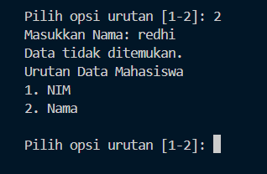

## Last menu(Exit)

to quit or exit the application